# 3D Printing Summary

|  |  |  |
| --- | --- | --- |
| **Metrics** | **Joystick housing only**  **(No optional prints)** | **All files including optional prints** |
| Total Print Time (h:min) | 3:11 | 5:33 |
| Total Number of Components | 4 | 10 |
| Typical Total Mass (g) | 27.7 | 45.9 |
| Typical Number of Print Setups | 1 | 1 |

# 3D Printing Settings

|  |  |  |  |  |  |  |  |
| --- | --- | --- | --- | --- | --- | --- | --- |
| **Print File Name** | **Qty** | **Total Print Time (hr:min)** | **Mass (g)** | **Infill (%)** | **Support (Y/N)** | **Layer Height/ Nozzle Diameter(mm)** | **Notes (orientation, special settings, etc.)** |
| Birch_Enclosure_  Bottom | 1 | 1:46 | 14.9 | 20 | N | 0.2/0.4 | Print in given orientation |
| Birch_Enclosure_Top | 1 | 1:07 | 10.6 | 20 | N | 0.2/0.4 | Print in given orientation |
| Inner_cover_disk | 1 | 0:04 | 0.5 | 20 | N | 0.2/0.4 | Print in given orientation |
| Overlay | 1 | 0:14 | 1.7 | 20 | N | 0.2/0.4 | Print in given orientation |
| **Optional Prints** | | | | | | | |
| Joystick_Camera_ Mount_Adapter | 1 | 0:54 | 8.5 | 20 | Y | 0.2/0.4 | Print in given orientation |
| Birch_Topper_Small_ dome | 1 | 0:08 | 0.6 | 20 | N | 0.2/0.4 | Print in given orientation |
| Birch_Topper_ Medium_dome | 1 | 0:17 | 1.7 | 20 | Y | 0.2/0.4 | Print in given orientation |
| Birch_Topper_Large_ dome | 1 | 0:37 | 4.9 | 20 | Y | 0.2/0.4 | Print in given orientation |
| Birch_Topper_Ring | 1 | 0:16 | 1.5 | 20 | Y | 0.2/0.4 | Print in given orientation, ring parallel to print bed |
| Birch_Topper_ Concave | 1 | 0:10 | 1.0 | 20 | N | 0.2/0.4 | Print in given orientation |

# Post-Processing

* Remove any bumps or zits from the surface where the enclosure meets the lid.
* Remove any bumps or zits from both surfaces of the inner cover disk. If any binding occurs between the joystick and the inner cover disk when assembling, sand down this part.
* Remove any supports from camera mount or toppers if printed.

# Customization Options

* Joystick housing can be printed in multiple colours.
* The joystick camera mount adapter is an optional add-on for mounting using ¼-20 threads
* The optional topper prints can customize the joystick for different users

# Examples of Quality Prints

## Birch_Enclosure_Bottom v0.2

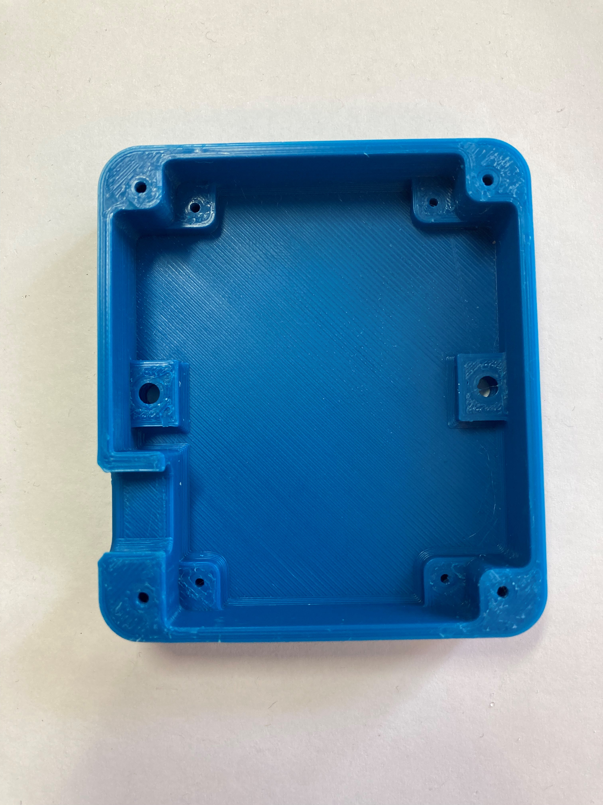 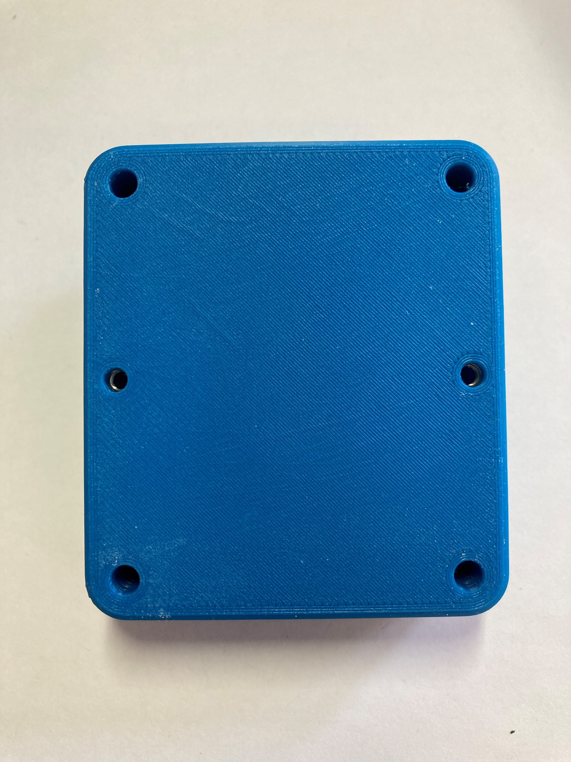

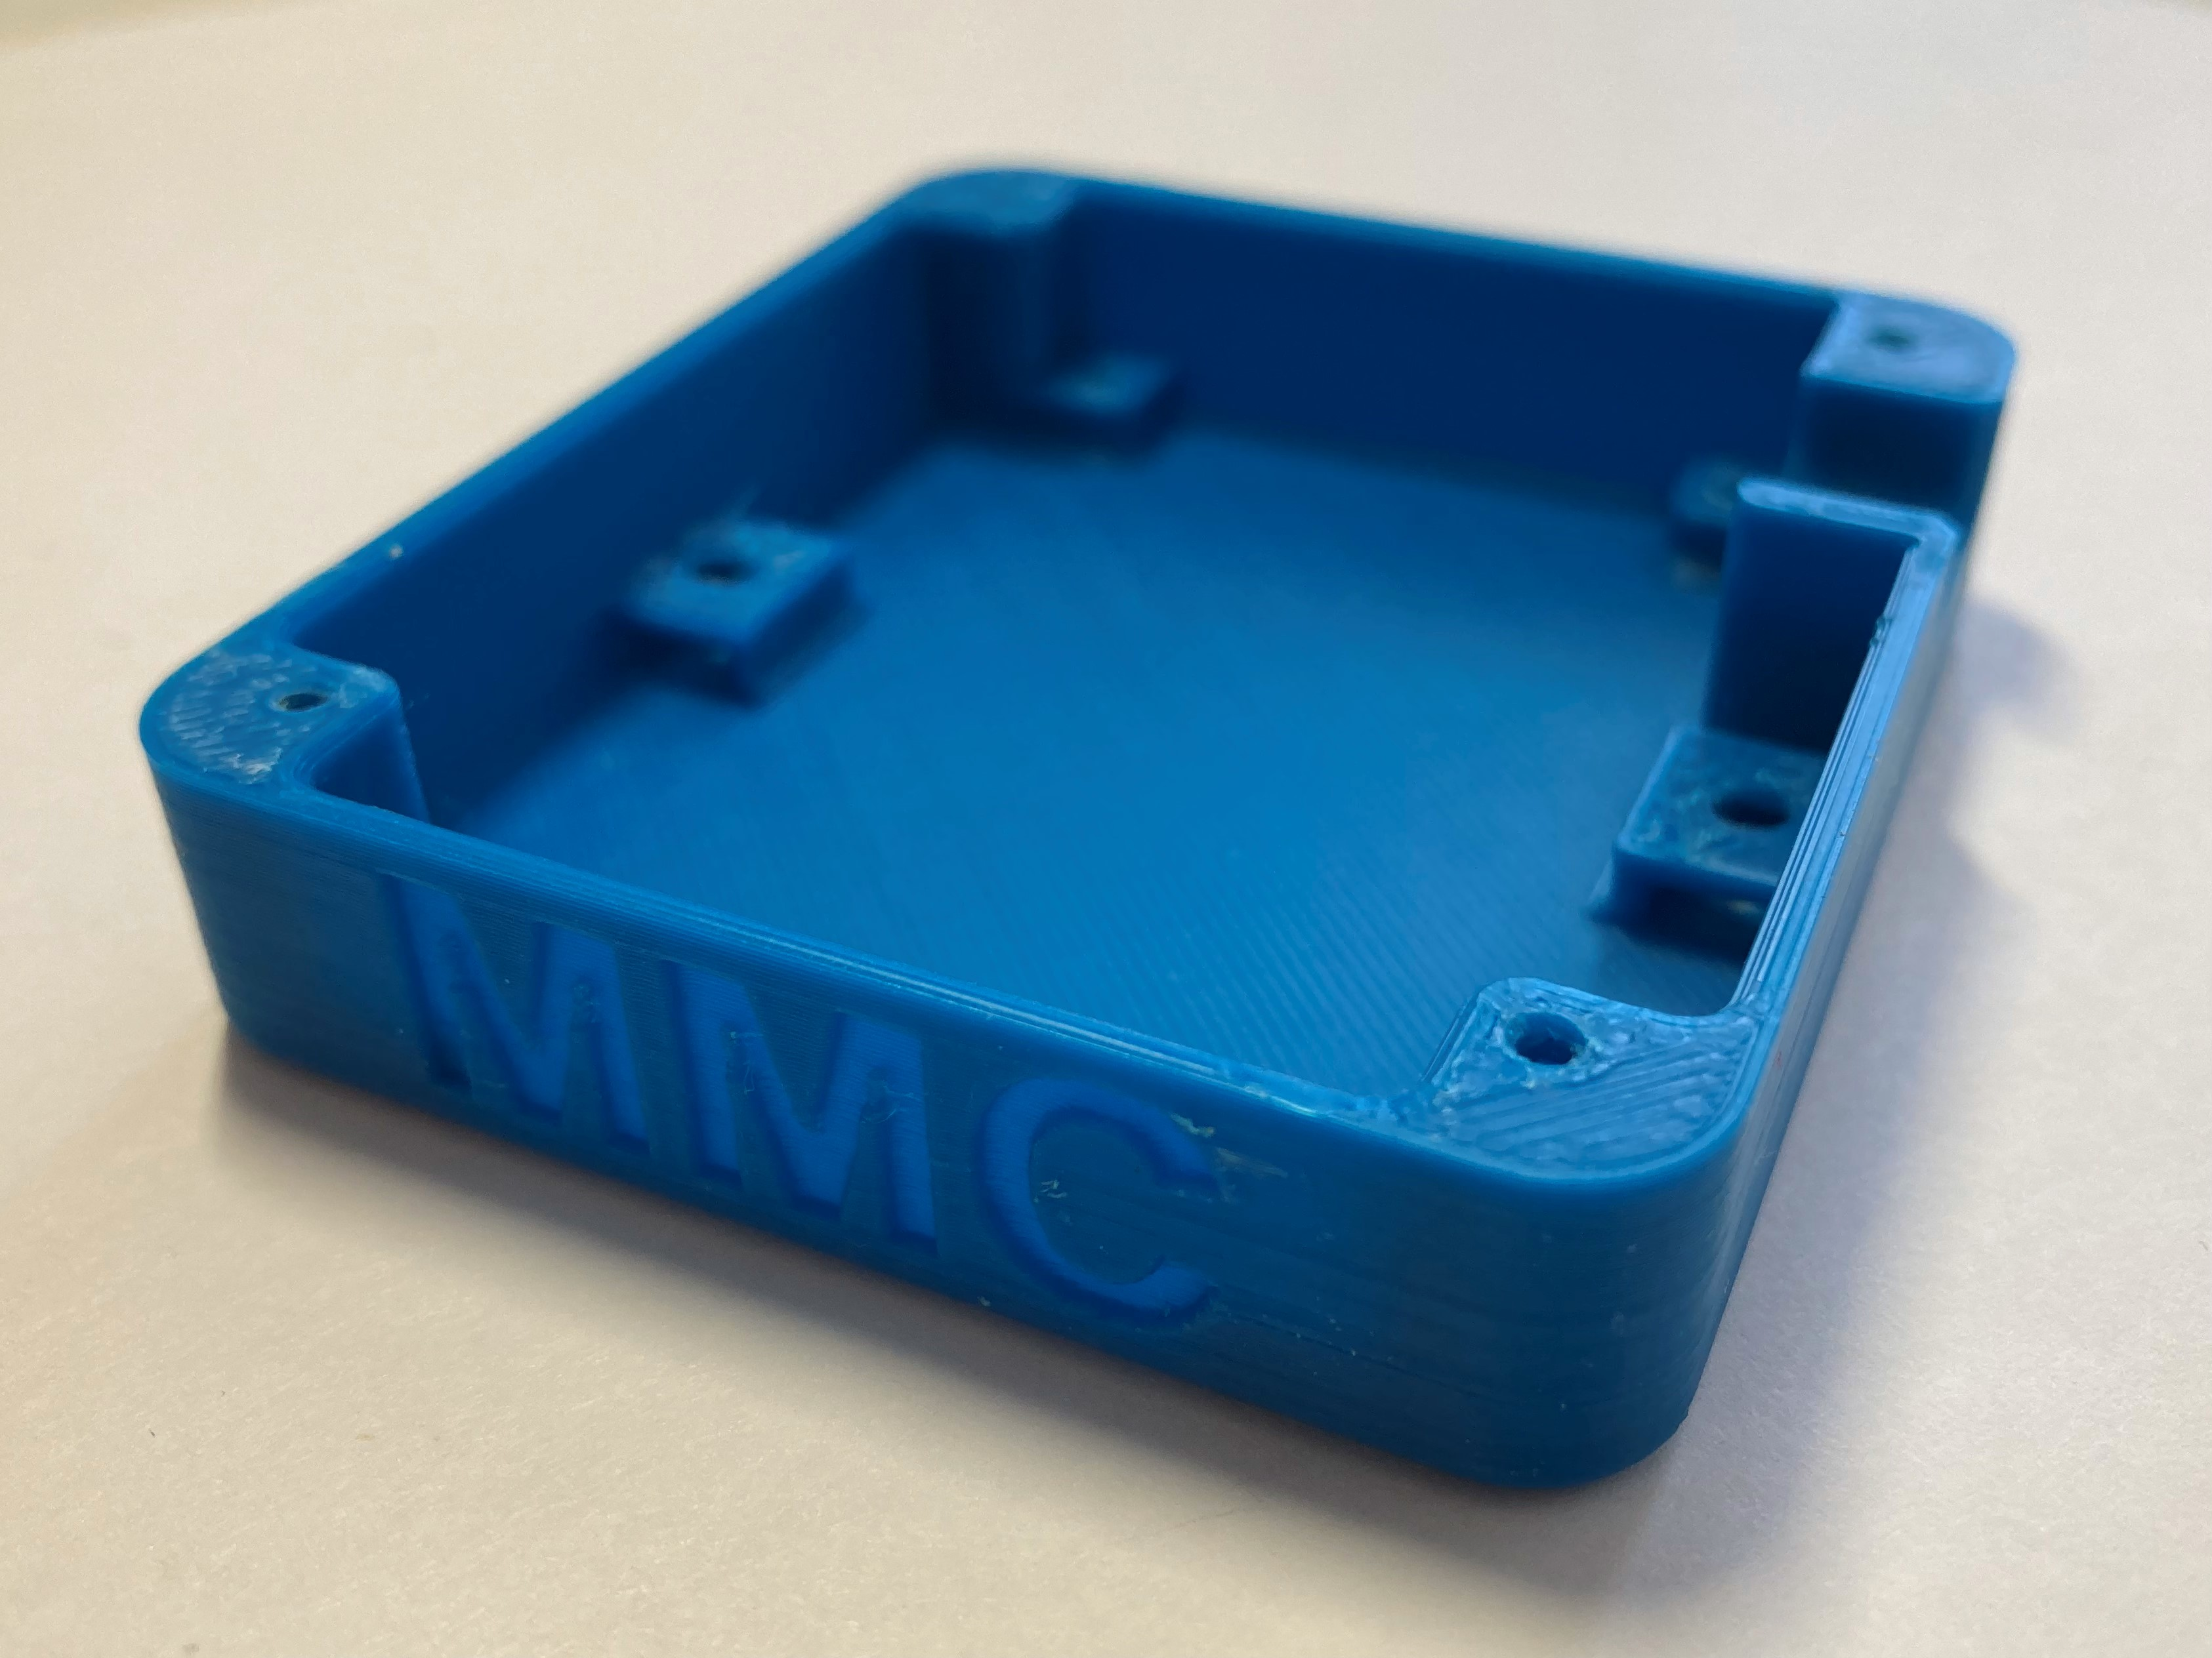

## Birch_Enclosure_Top v0.2

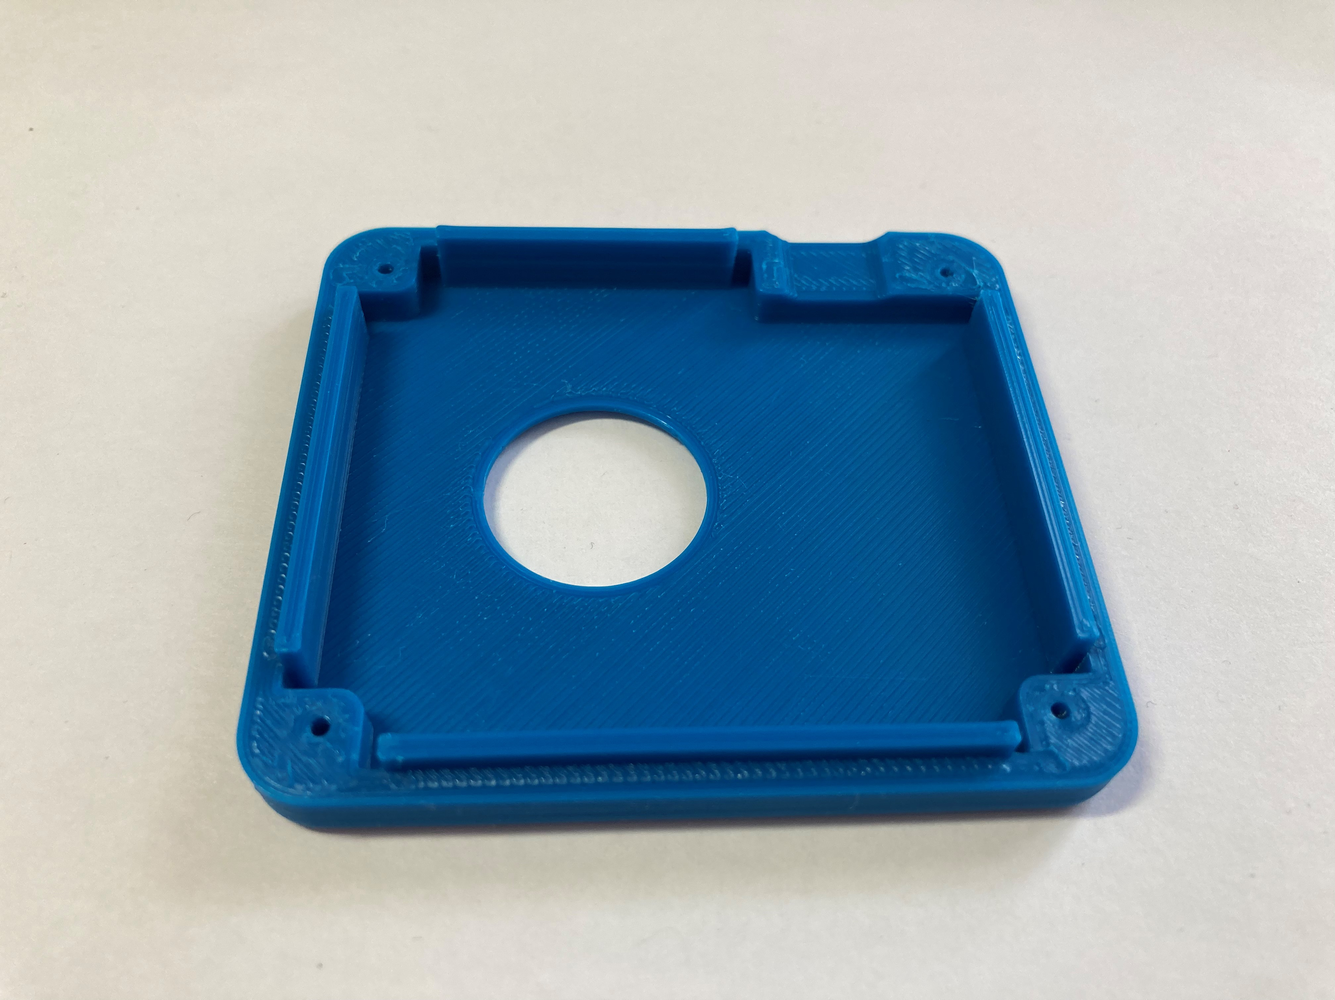

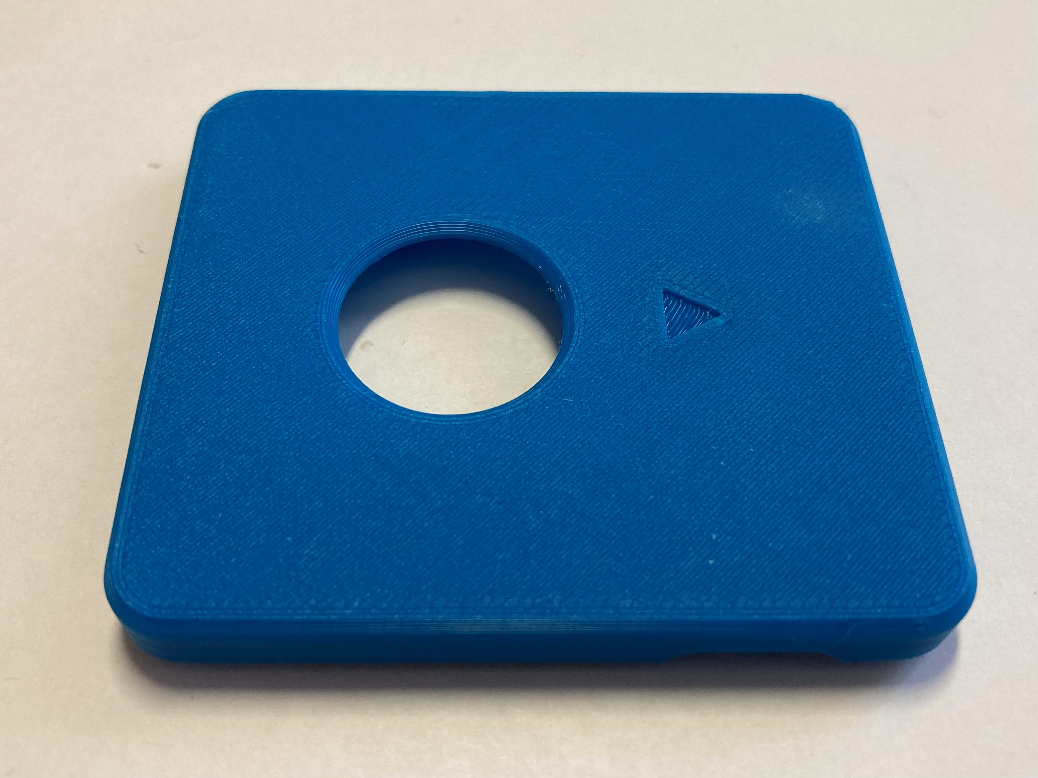

## Inner_Cover_Disk v0.2

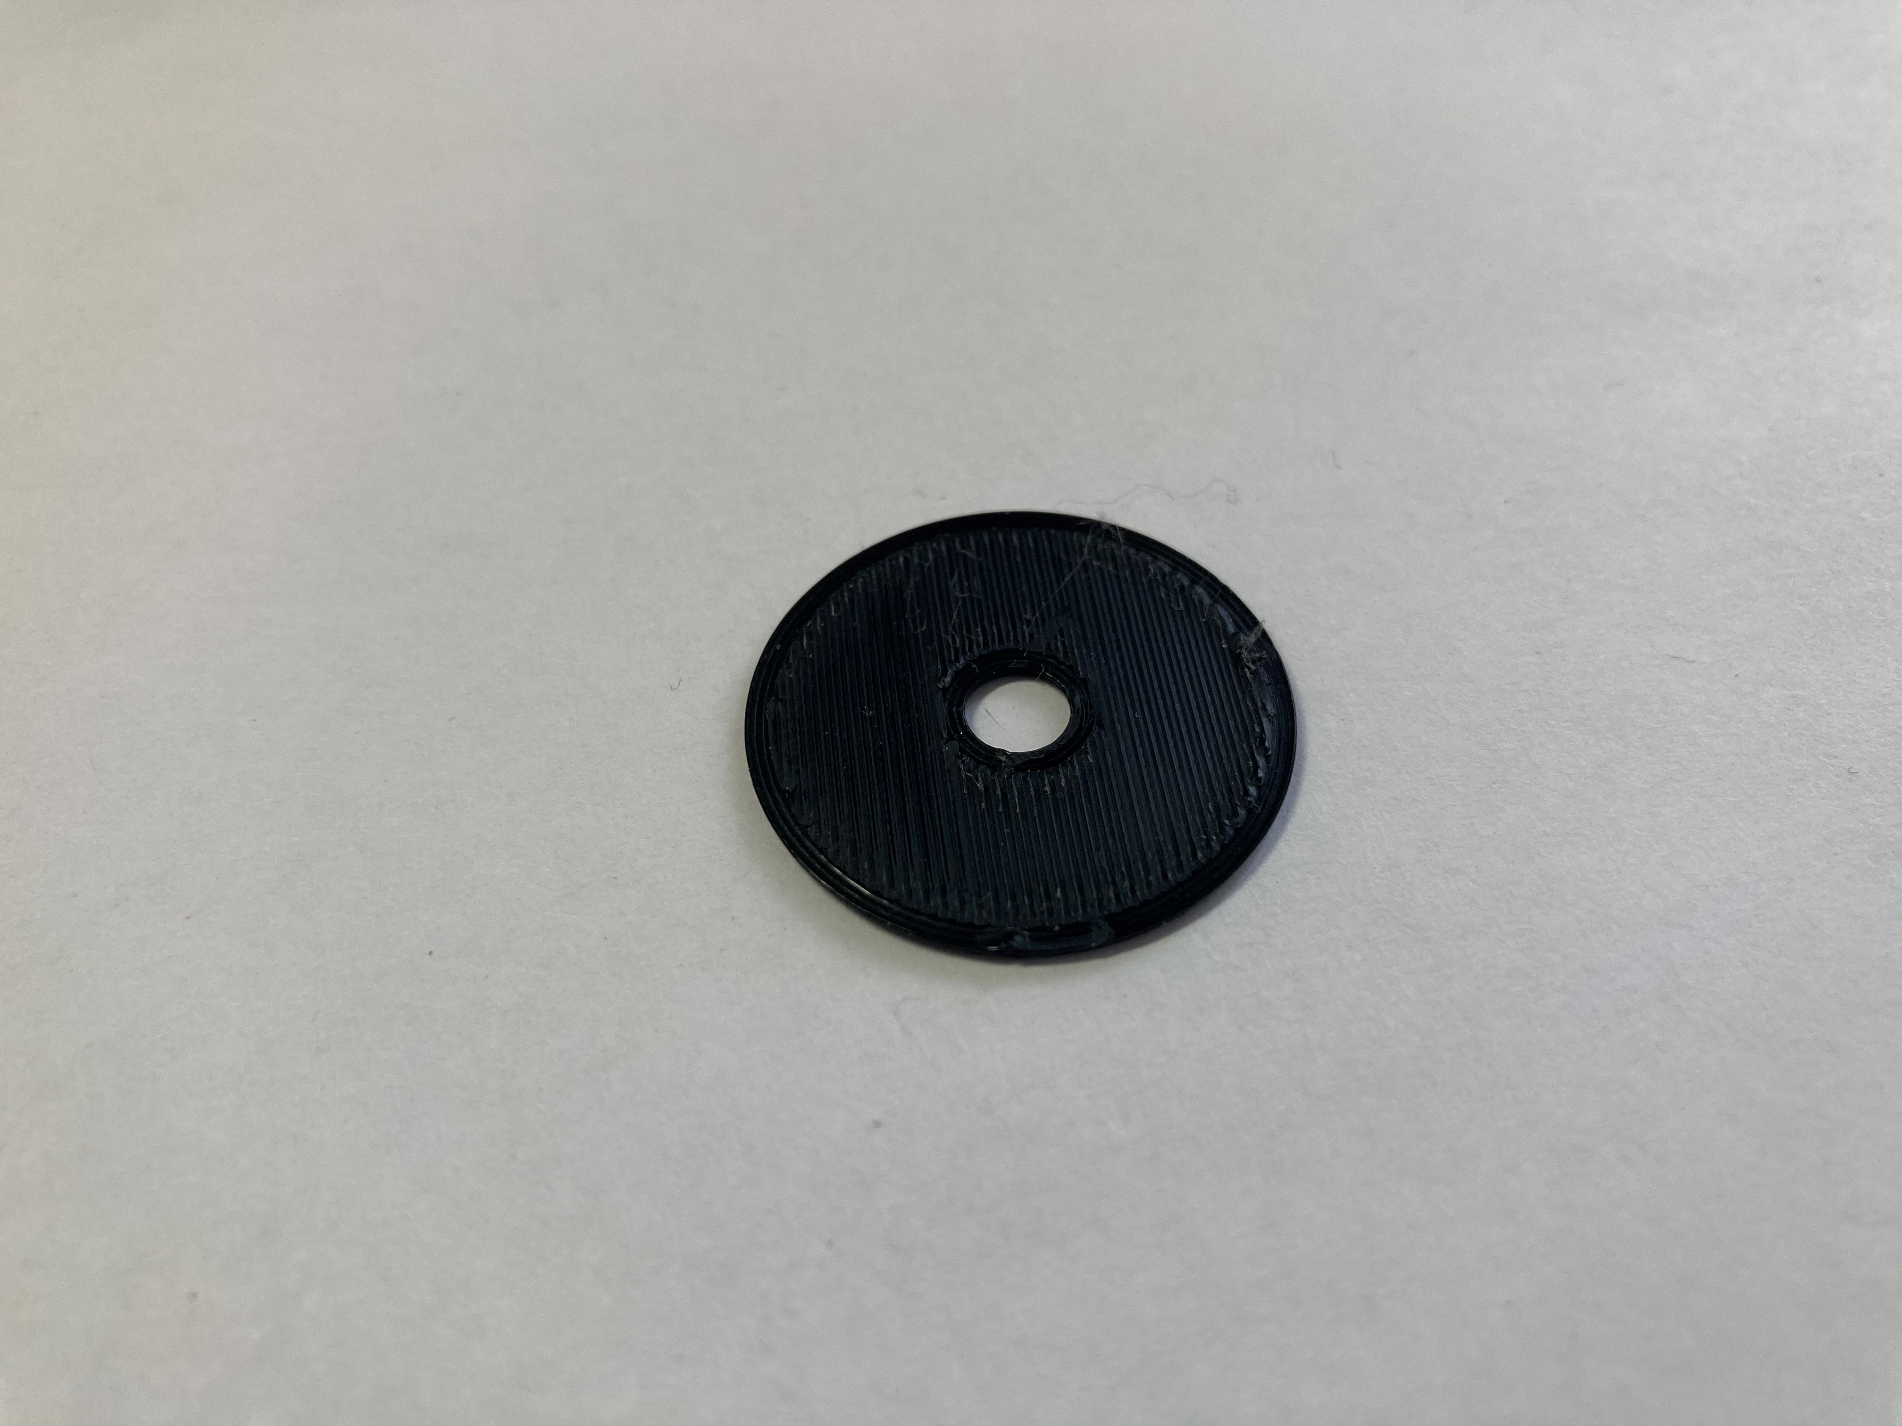

## Overlay v0.2

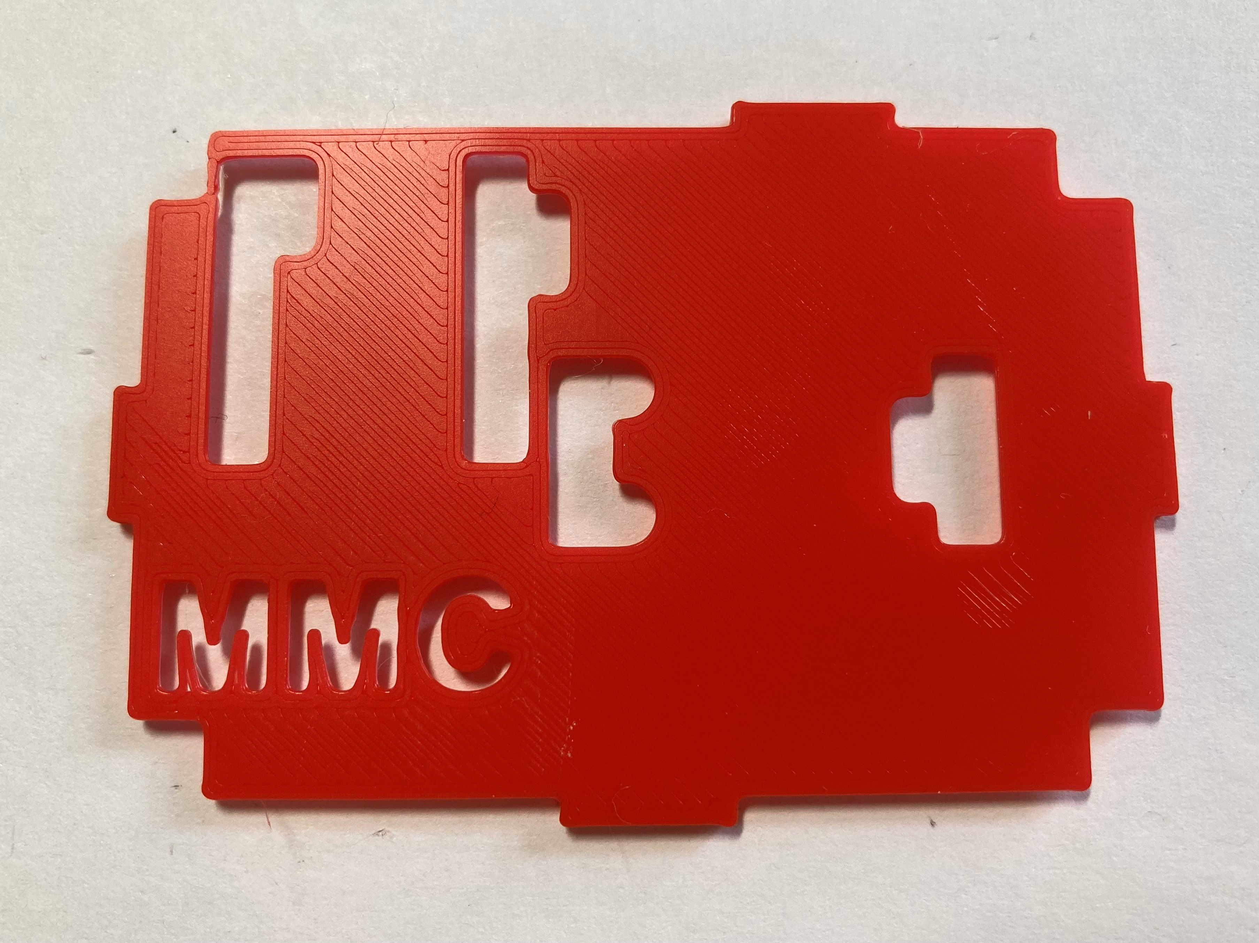 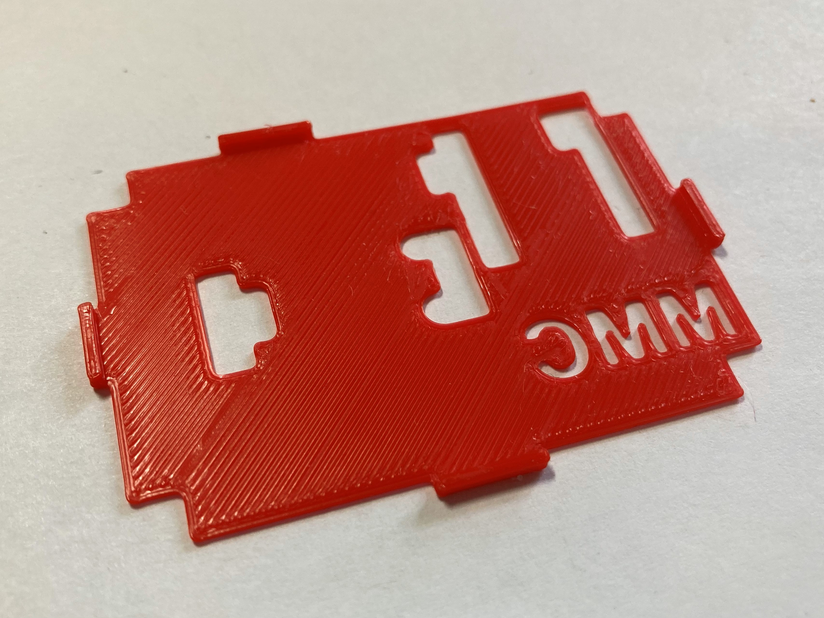

## Joystick Camera Mount Adapter

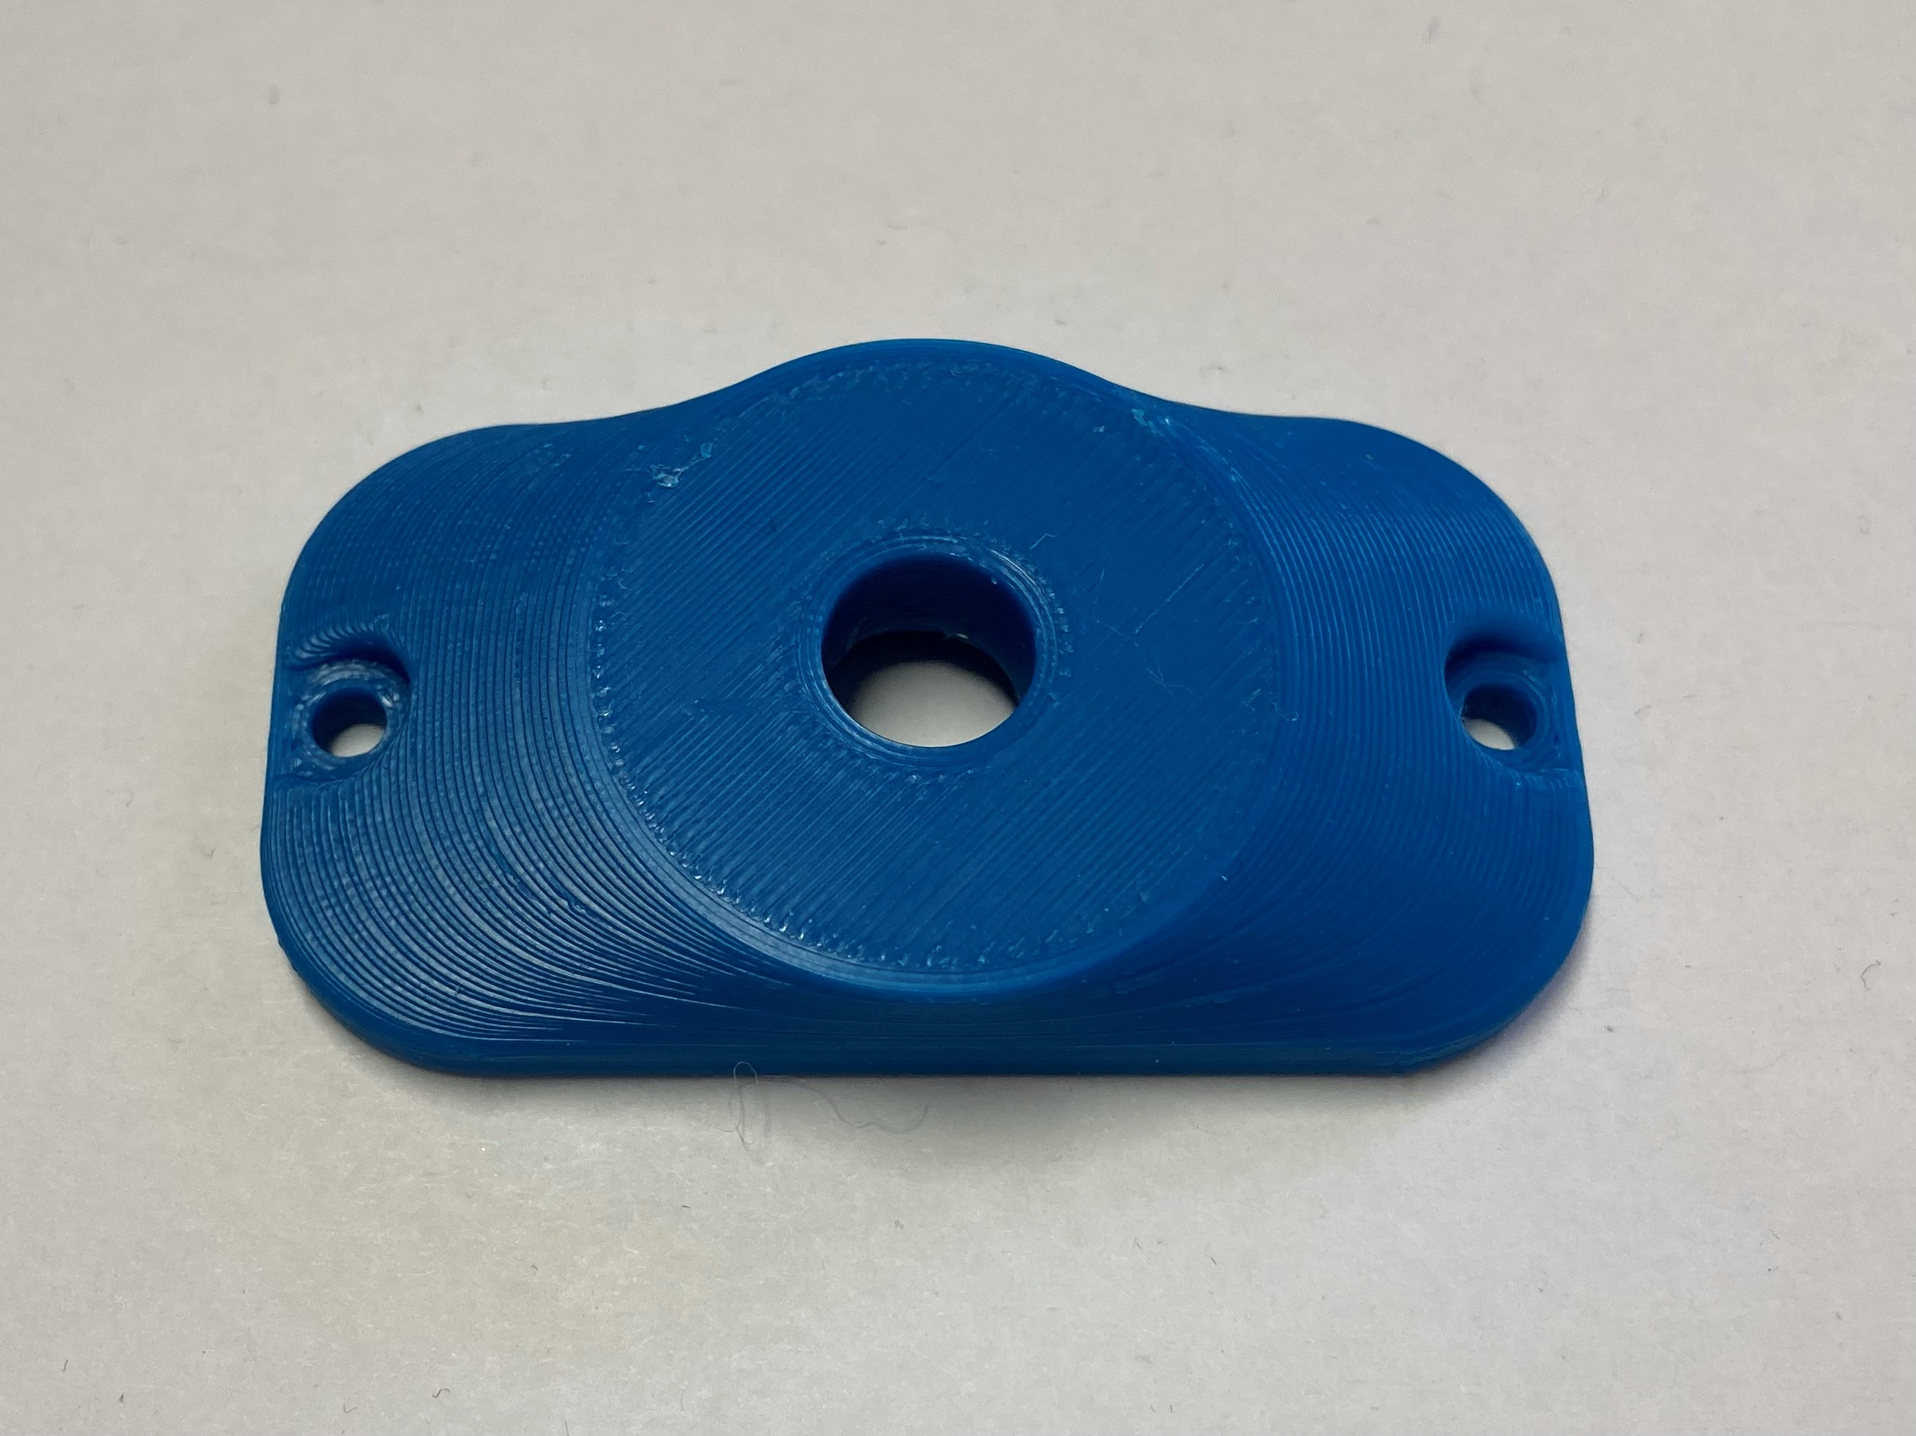 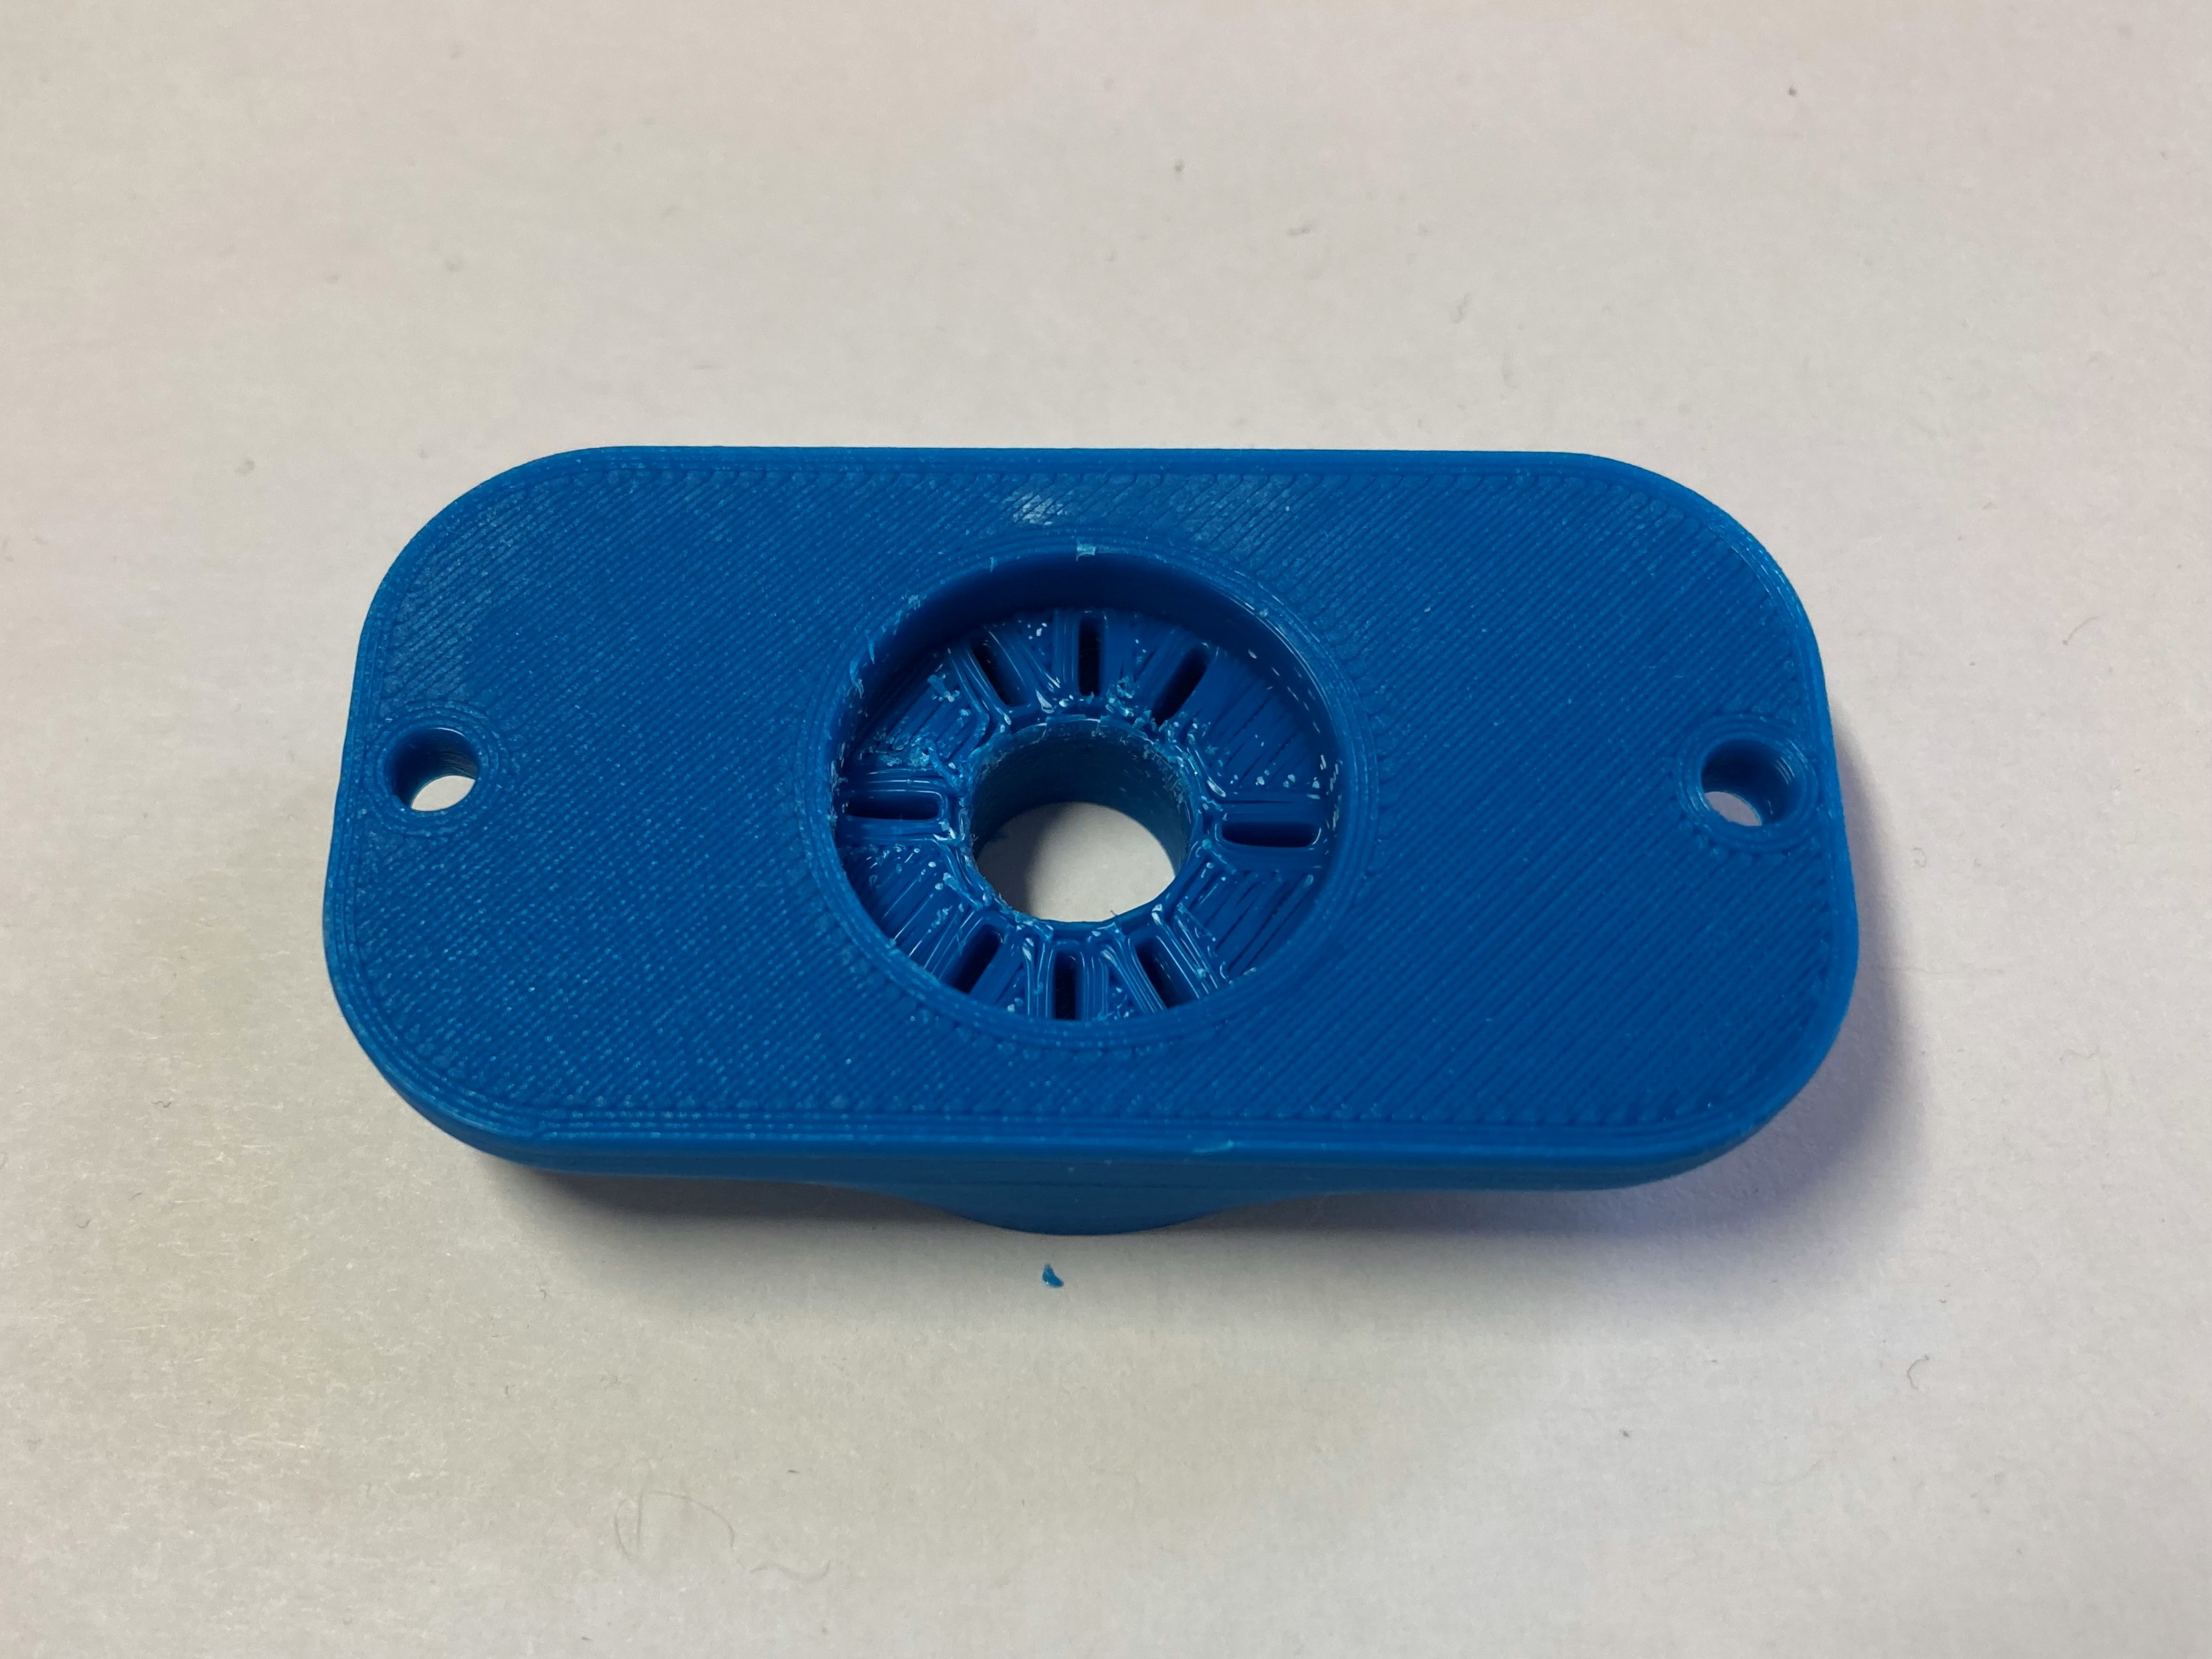

## Joystick toppers

